This homework assignment is based on Chapter 7 Lists and Tuples.

**There are 5 print screens each is worth 20%**

**Project #1**

Print the minimum or smallest number from the following list using the min function

my_list = [5, 4, 3, 2, 50, 40, 30]

**#1 print screen the output with code below here.**

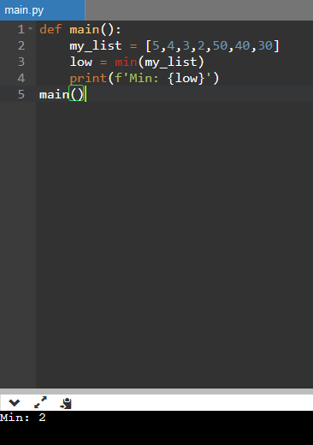

**Project #2**

Print the maximum or biggest number from the following list using the max function

my_list = [5, 4, 3, 2, 50, 40, 30]

**#2 print screen the output with code below here.**

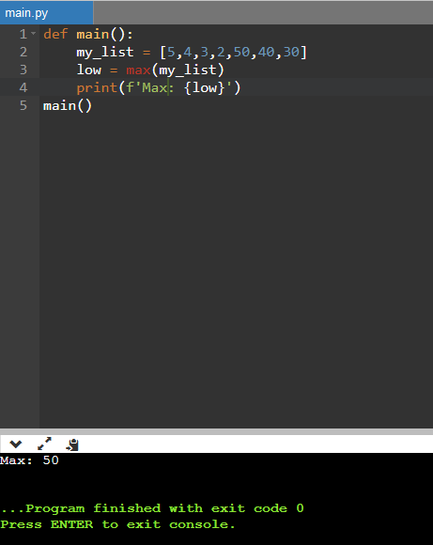

**Project #3**

Get the sum and average from the list below

scores = [2.5, 7.3, 6.5, 4.0, 5.2]

**#3 print screen the output with code below here.**

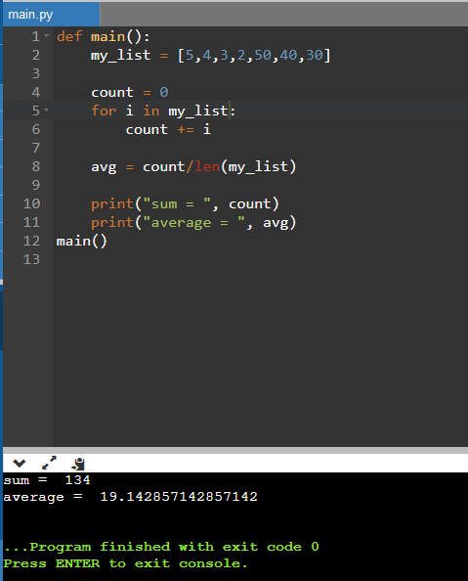

**Project #4**

Below is a 2-D list of names, retrieve the name **Joe**. The two empty brackets will have to be filled with numbers.

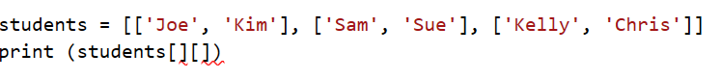

retrieve the name **Sam**.

retrieve the name **Chris.**

**#4 print screen the output with code below here.**

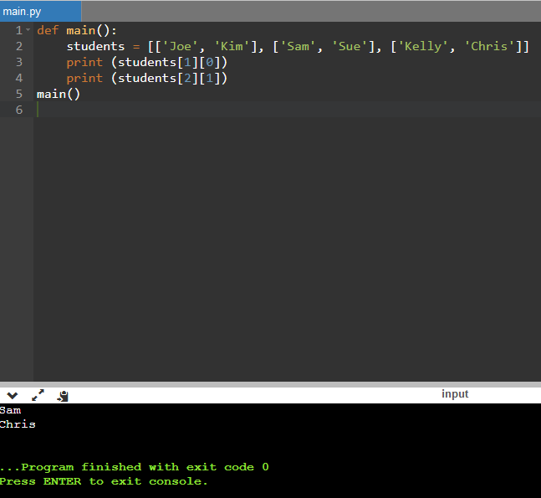

**Project #5**

Below is a 2-d list of numbers, sum and average all the numbers.

**#5 print screen the output with code below here.**

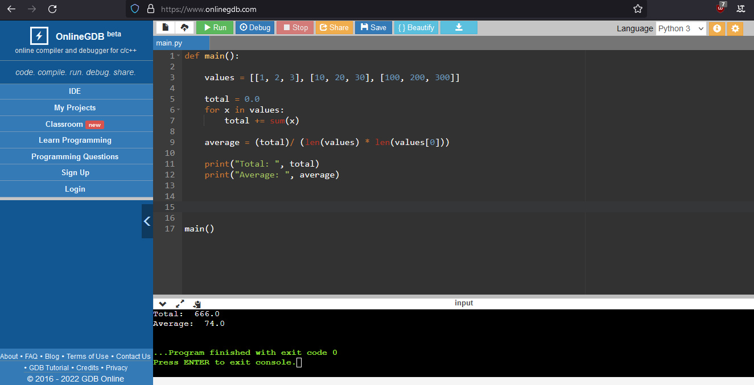

**Submit this document to module 8 homework.**